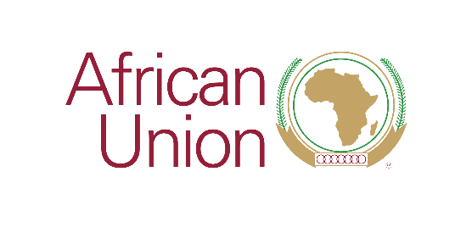
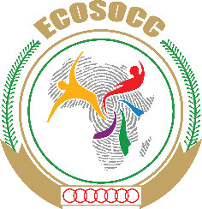

Press Release No: 2 /2020 Date: November 16, 2020

Venue: Chisamba, Zambia

AU-ECOSOCC and COMESA hold consultations with Zambian CSOs on peace and security initiatives

The African Union’s Economic, Social and Cultural Council (AU-ECOSOCC) and the Common Market for Eastern and Southern Africa (COMESA) are holding consultations with Civil Society Organizations (CSOs) in Zambia to enhance partnerships and collaboration in peace and security initiatives.

The consultations being held from 16th – 21st November 2020, are meant to strengthen the two Organs’ collaboration with CSOs within the framework of the AU theme of the year 2020: ‘Silencing the Guns: Creating Conducive Conditions for Africa’s Development.’
Further, the consultations provide an opportunity for ECOSOCC and COMESA to identify program synergies and opportunities for technical cooperation. In addition to developing a joint roadmap to support the development of a CSO accreditation mechanism at the regional and continental level, the two institutions will also undertake a planning session with the Zambian National Structural Vulnerability Assessment Bureau to support the Republic of Zambia’s impending Country Structural Vulnerability and Resilience Assessment under the framework of the COMESA Early Warning System (COMWARN).

In his opening remarks, ECOSOCC Head of Programmes, Kyeretwie Osei, stressed the key role that civil society plays in helping operationalize the people-centred aspiration of the African Union, explaining that ECOSOCC was committed to the consultations as they are aligned to the AU 2020 theme of the year.

ECOSOCC has been actively involved in crucial AU peace and security programs, including but not limited to: countering violent extremism, terrorism and the illicit proliferation of Small Arms and Light Weapons (SALW) in Africa through the operationalization of the Livingstone Formula which provides a roadmap for civil society participation in peace and security efforts in Africa; the development of technical advisory opinions to the AU Peace and Security Council (PSC) on strategies for ensuring peace, security, and stability on the continent; and helping drive the delivery of the Security Sector Reform (SSR) agenda being implemented under the auspices of the African Union Commission’s Peace and Security Department..

“It is critical to have an institutional mechanism for the accreditation of civil society organizations and I am glad that both ECOSOCC and COMESA have ongoing projects for the accreditation of CSOs,” he said.

Mr. Osei reiterated ECOSOCC’s commitment to collaborate with COMESA to ensure the development of a harmonized mechanism for the accreditation of CSOs at the regional and continental levels.

He further thanked the Government and People of the Republic of Zambia for the hospitality and support extended to ECOSOCC during its relocation and establishment of its standalone Secretariat in Lusaka, Zambia.
#

About the African Union
The African Union (AU) is a continental body consisting of the 55 Member States that make up the countries of the African Continent. It was officially launched in 2002 as a successor to the Organisation of African Unity (OAU, 1963-1999).
About ECOSOCC
The Economic, Social and Cultural Council (ECOSOCC) was established in July 2004 as an Advisory Organ composed of different social and professional groups of AU Member States. The mandate of ECOSOCC is to contribute, through advice, to the effective translation of the objectives, principles and policies of the African Union into concrete programmes, as well as the evaluation of these programmes.;.
Learn more at: https://au.int/en/about/ecosocc; https://www.auecosocc.org;
Facebook: African Union ECOSOCC; Twitter: @AU_ECOSOCC

For media inquiries, please contact:
Ms. Carol Jilombo | Senior Communications Officer | AU ECOSOCC Secretariat, Lusaka, Zambia
E-mail: Jilomboc@africa-union.org

